SQL Data Types

🌟 Definition
# Source: AI Source: Provided by: [Data Path: Persons Table -> ID Column: 1, Name_En Column: Motasem Essam] -> From: [ChatGPT] on [6/11/2026]
SQL Data Types define the kind of data that can be stored in a table column.
Every column in a table must have a data type.
The data type determines:
- What values can be stored
- How much storage is used
- How the database processes the data

🎯 Purpose
# Source: AI Source: Provided by: [Data Path: Persons Table -> ID Column: 1, Name_En Column: Motasem Essam] -> From: [ChatGPT] on [6/11/2026]
Data types help:
- Store data correctly
- Validate input
- Improve performance
- Save storage space
- Prevent invalid values

🧠 Simple Example
# Source: AI Source: Provided by: [Data Path: Persons Table -> ID Column: 1, Name_En Column: Motasem Essam] -> From: [ChatGPT] on [6/11/2026]
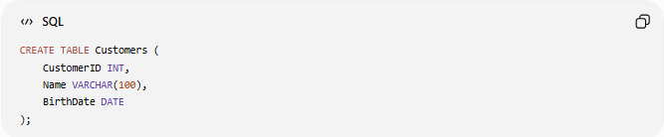
CREATE TABLE Customers (
CustomerID INT,
Name VARCHAR(100),
BirthDate DATE
);
Here:
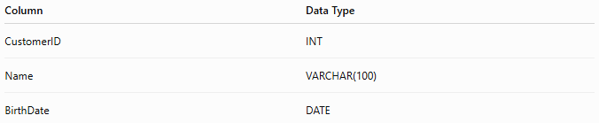
Column | Data Type
CustomerID | INT
Name | VARCHAR(100)
BirthDate | DATE

📚 Main Categories of SQL Data Types
# Source: AI Source: Provided by: [Data Path: Persons Table -> ID Column: 1, Name_En Column: Motasem Essam] -> From: [ChatGPT] on [6/11/2026]
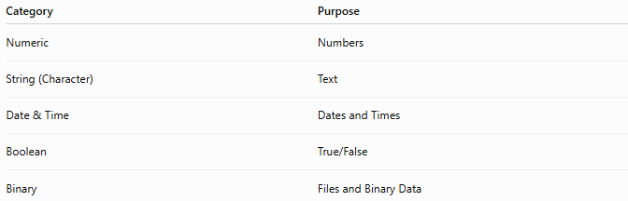
Category | Purpose
Numeric | Numbers
String (Character) | Text
Date & Time | Dates and Times
Boolean | True/False
Binary | Files and Binary Data

1️⃣ 🔢 Numeric Data Types
# Source: AI Source: Provided by: [Data Path: Persons Table -> ID Column: 1, Name_En Column: Motasem Essam] -> From: [ChatGPT] on [6/11/2026]
Used for storing numbers.

INT
# Source: AI Source: Provided by: [Data Path: Persons Table -> ID Column: 1, Name_En Column: Motasem Essam] -> From: [ChatGPT] on [6/11/2026]
Stores whole numbers.
Example:
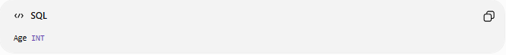
Age INT
Valid values:
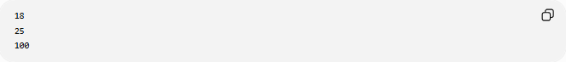
18
25
100

Example Table
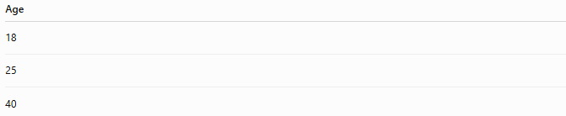
Age
18
25
40

DECIMAL
# Source: AI Source: Provided by: [Data Path: Persons Table -> ID Column: 1, Name_En Column: Motasem Essam] -> From: [ChatGPT] on [6/11/2026]
Stores exact decimal values.
Example:
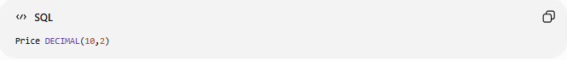
Price DECIMAL(10,2)
Meaning:
10 digits total
2 digits after decimal point

Valid:
99.99
1500.50

FLOAT
# Source: AI Source: Provided by: [Data Path: Persons Table -> ID Column: 1, Name_En Column: Motasem Essam] -> From: [ChatGPT] on [6/11/2026]
Stores approximate decimal values.
Example:
Temperature FLOAT
Used for scientific calculations.

Common Numeric Types
# Source: AI Source: Provided by: [Data Path: Persons Table -> ID Column: 1, Name_En Column: Motasem Essam] -> From: [ChatGPT] on [6/11/2026]
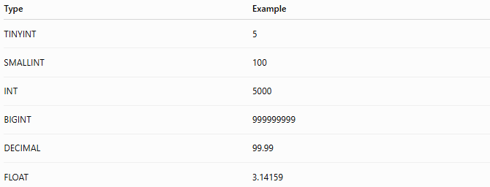
Type | Example
TINYINT | 5
SMALLINT | 100
INT | 5000
BIGINT | 999999999
DECIMAL | 99.99
FLOAT | 3.14159

2️⃣ 📝 String (Character) Data Types
# Source: AI Source: Provided by: [Data Path: Persons Table -> ID Column: 1, Name_En Column: Motasem Essam] -> From: [ChatGPT] on [6/11/2026]
Used for storing text.

CHAR
# Source: AI Source: Provided by: [Data Path: Persons Table -> ID Column: 1, Name_En Column: Motasem Essam] -> From: [ChatGPT] on [6/11/2026]
Fixed-length text.
Example:
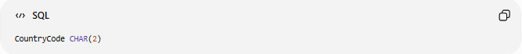
CountryCode CHAR(2)
Valid:

US
EG
UK
Always stores exactly 2 characters.

VARCHAR
# Source: AI Source: Provided by: [Data Path: Persons Table -> ID Column: 1, Name_En Column: Motasem Essam] -> From: [ChatGPT] on [6/11/2026]
Variable-length text.
Example:
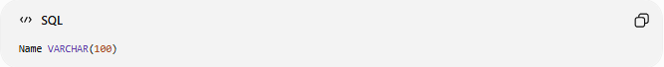
Name VARCHAR(100)
Valid:
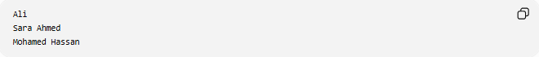
Ali
Sara Ahmed
Mohamed Hassan
Stores only the characters used.

TEXT
# Source: AI Source: Provided by: [Data Path: Persons Table -> ID Column: 1, Name_En Column: Motasem Essam] -> From: [ChatGPT] on [6/11/2026]
Stores large amounts of text.
Example:
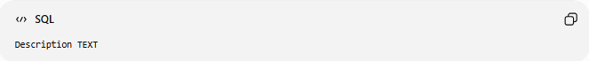
Description TEXT
Used for:
- Articles
- Blog posts
- Comments

Common String Types
# Source: AI Source: Provided by: [Data Path: Persons Table -> ID Column: 1, Name_En Column: Motasem Essam] -> From: [ChatGPT] on [6/11/2026]
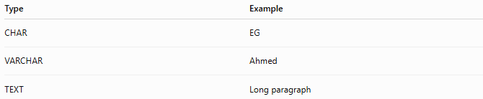
Type | Example
CHAR | EG
VARCHAR | Ahmed
TEXT | Long paragraph

3️⃣ 📅 Date & Time Data Types
# Source: AI Source: Provided by: [Data Path: Persons Table -> ID Column: 1, Name_En Column: Motasem Essam] -> From: [ChatGPT] on [6/11/2026]
Used for dates and times.

DATE
# Source: AI Source: Provided by: [Data Path: Persons Table -> ID Column: 1, Name_En Column: Motasem Essam] -> From: [ChatGPT] on [6/11/2026]
Stores only a date.
Example:
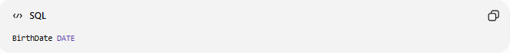
BirthDate DATE
Value:
2026-06-16

TIME
# Source: AI Source: Provided by: [Data Path: Persons Table -> ID Column: 1, Name_En Column: Motasem Essam] -> From: [ChatGPT] on [6/11/2026]
Stores only time.
Example:
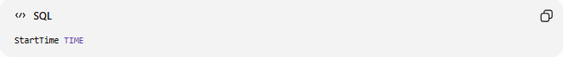
StartTime TIME
Value:
14:30:00

DATETIME
# Source: AI Source: Provided by: [Data Path: Persons Table -> ID Column: 1, Name_En Column: Motasem Essam] -> From: [ChatGPT] on [6/11/2026]
Stores date and time.
Example:
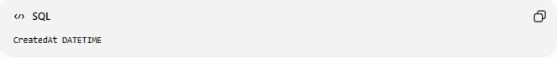
CreatedAt DATETIME
Value:
2026-06-16 14:30:00

TIMESTAMP
# Source: AI Source: Provided by: [Data Path: Persons Table -> ID Column: 1, Name_En Column: Motasem Essam] -> From: [ChatGPT] on [6/11/2026]
Often used for record creation dates.
Example:
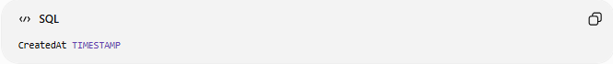
CreatedAt TIMESTAMP

Common Date Types
# Source: AI Source: Provided by: [Data Path: Persons Table -> ID Column: 1, Name_En Column: Motasem Essam] -> From: [ChatGPT] on [6/11/2026]
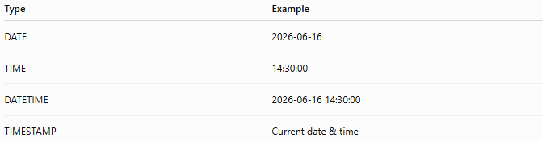
Type | Example
DATE | 2026-06-16
TIME | 14:30:00
DATETIME | 2026-06-16 14:30:00
TIMESTAMP | Current date & time

4️⃣ ✅ Boolean Data Type
# Source: AI Source: Provided by: [Data Path: Persons Table -> ID Column: 1, Name_En Column: Motasem Essam] -> From: [ChatGPT] on [6/11/2026]
Stores:
TRUE
FALSE
Example:
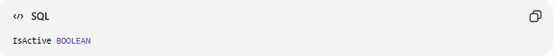
IsActive BOOLEAN

Values:
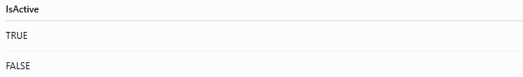
IsActive
TRUE
FALSE

In some databases:
TRUE = 1
FALSE = 0

5️⃣ 📦 Binary Data Types
# Source: AI Source: Provided by: [Data Path: Persons Table -> ID Column: 1, Name_En Column: Motasem Essam] -> From: [ChatGPT] on [6/11/2026]
Used for files and binary data.
Examples:
- Images
- PDFs
- Audio
- Videos

BLOB
Binary Large Object.
Example:
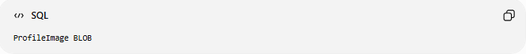
ProfileImage BLOB
Stores image data directly in the database.

📊 Side-by-Side Comparison
# Source: AI Source: Provided by: [Data Path: Persons Table -> ID Column: 1, Name_En Column: Motasem Essam] -> From: [ChatGPT] on [6/11/2026]
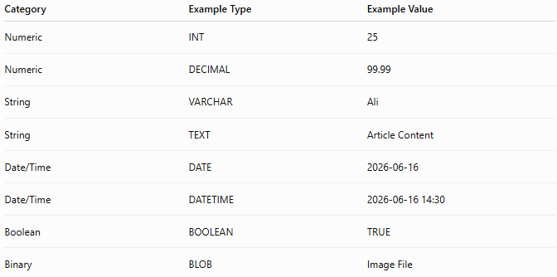
Category | Example Type | Example Value
Numeric | INT | 25
Numeric | DECIMAL | 99.99
String | VARCHAR | Ali
String | TEXT | Article Content
Date/Time | DATE | 2026-06-16
Date/Time | DATETIME | 2026-06-16 14:30
Boolean | BOOLEAN | TRUE
Binary | BLOB | Image File

🛠️ Complete Example
# Source: AI Source: Provided by: [Data Path: Persons Table -> ID Column: 1, Name_En Column: Motasem Essam] -> From: [ChatGPT] on [6/11/2026]
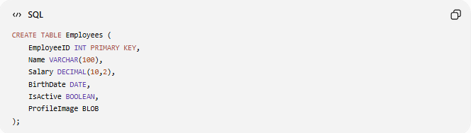
CREATE TABLE Employees (
EmployeeID INT PRIMARY KEY,
Name VARCHAR(100),
Salary DECIMAL(10,2),
BirthDate DATE,
IsActive BOOLEAN,
ProfileImage BLOB
);

Column Breakdown
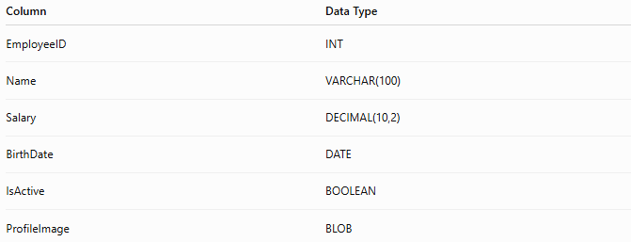
Column | Data Type
EmployeeID | INT
Name | VARCHAR(100)
Salary | DECIMAL(10,2)
BirthDate | DATE
IsActive | BOOLEAN
ProfileImage | BLOB

⚠️ Choosing the Right Data Type
# Source: AI Source: Provided by: [Data Path: Persons Table -> ID Column: 1, Name_En Column: Motasem Essam] -> From: [ChatGPT] on [6/11/2026]
Good
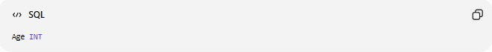
Age INT
Stores numbers efficiently.

Bad
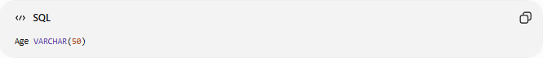
Age VARCHAR(50)
Stores numbers as text.
Less efficient and harder to validate.

📚 Commonly Used SQL Data Types
# Source: AI Source: Provided by: [Data Path: Persons Table -> ID Column: 1, Name_En Column: Motasem Essam] -> From: [ChatGPT] on [6/11/2026]
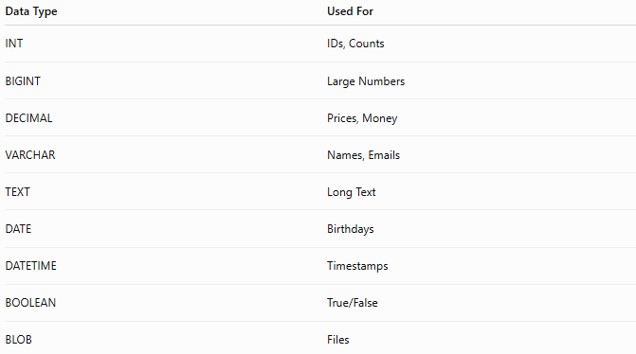
Data Type | Used For
INT | IDs, Counts
BIGINT | Large Numbers
DECIMAL | Prices, Money
VARCHAR | Names, Emails
TEXT | Long Text
DATE | Birthdays
DATETIME | Timestamps
BOOLEAN | True/False
BLOB | Files

🧠 Simple Analogy
# Source: AI Source: Provided by: [Data Path: Persons Table -> ID Column: 1, Name_En Column: Motasem Essam] -> From: [ChatGPT] on [6/11/2026]
Think of a filing cabinet.
Different drawers store different types of items:
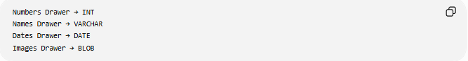
Numbers Drawer → INT
Names Drawer → VARCHAR
Dates Drawer → DATE
Images Drawer → BLOB
You wouldn't store a photograph in the numbers drawer.
Similarly, each SQL column should use the correct data type.

🧭 Summary
# Source: AI Source: Provided by: [Data Path: Persons Table -> ID Column: 1, Name_En Column: Motasem Essam] -> From: [ChatGPT] on [6/11/2026]
SQL Data Types define the type of data that can be stored in a database column. Major categories include Numeric (INT, DECIMAL), String (VARCHAR, TEXT), Date & Time (DATE, DATETIME), Boolean (TRUE/FALSE), and Binary (BLOB). Choosing the correct data type improves data integrity, performance, and storage efficiency.

